NOBLESTRIDE CAPITAL

NOBLESTRIDE CAPITAL
Create. Value. Investing. Sub-Saharan Africa

18th December 2024
CONFIDENTIAL
Process at Noblestride Capital
End-to-end Client Onboarding and Fundraising Workflow

Stage 1: Onboarding Process
- Confidentiality Agreement:
Execute a Non-Disclosure Agreement (NDA) to ensure confidentiality of shared information.
- Data Collection:
Request preliminary data, including but not limited to:
- Company profile
- Audited financial statements
- Key performance indicators (KPIs)
- Management accounts
- Initial Assessment:
Perform a high-level financial review to evaluate suitability for onboarding:
- Proceed: Advance to step 4 below.
- Terminate: Conclude discussions if not viable and issue a regret email to inform the client of the decision to terminate the engagement.
- Engagement Agreement:
Formalize the engagement with a signed agreement that outlines:
- Scope of work
- Fee structure and terms

Stage 2: Investment Document Preparation
- Preparation of Key Documents:
- Teaser/Pitch Deck: A 2–3page document to test investor interest.
- Detailed Financial Analysis: Comprehensive evaluation of financial health and projections.
- Financial Model: A robust model capturing business scenarios and valuation.
- Valuation Report: Supports equity discussions with investors.
- Business Plan: A detailed document outlining strategy, operations, and financials.
- Review Process:
- Peer Review: Share documents with a colleague for quality assurance and feedback.
- Approval: Submit revised documents to the Managing Director for review and approval.
- Client Review: Share approved documents with the client for input and incorporate feedback.
- Finalization:
Save finalized versions for sharing to potential investors.

Stage 3: Engaging the Market
- Investor Outreach:
Share the teaser document through:
- Email
- Virtual calls
- Physical meetings
- Expression of Interest and Signing of NDA:
Expressions of interest are submitted by potential investors, followed by the signing of an NDA. There are two types of NDAs:
- Open NDA: Signed between the investor and Noblestride Capital, granting the investor access to multiple data rooms upon request without the need for additional NDAs.
- Closed NDA: Signed among the investor, Noblestride Capital, and/or the specific client. This type restricts the investor's access to only one specific data room. Additional NDAs are required for access to other data rooms.
- Information Sharing:
- Circulate the Confidential Information Memorandum (IM) to interested investors.
- Address queries and arrange introductory meetings between investors and the client.
- Provide secure and timely access to the data room upon investor request.
- Due Diligence:
Stages:
- Desktop Due Diligence:
Investors review documents, seek clarifications, and engage in Q&A sessions.
- Onsite Due Diligence:
Physical site visits by investors or their representatives.
Types of Due Diligence:
- Financial due diligence.
- Environmental due diligence.
- Legal due diligence.
- Commercial diligence
- Tax Due diligence

- Negotiation and Offers:
  - Facilitate submission of binding offers from interested investors.
  - Lead negotiations on commercial terms.
  - If the transaction is a debt transaction
    - Preparation and negotiation of the loan agreement
  - If the transaction is an equity transaction
    - Preparation of shareholders agreement (SHA)
    - Preparation of share purchase agreements (SPA)
    - Notification and filling of the transaction at the competition authority of Kenya (CAK) or COMESA

Stage 4: Transaction Closure:
Draft and execute definitive agreements based on the financing type:
- Loan Financing: Credit facility agreement
- Equity Financing: Shareholders' agreement
Disbursement.
Invoicing for the success fee and receipt of the payment as agreed on the engagement contract.

Summarised process- From (Noblestride Capital) “the advisors” perspective
- Sharing of the teaser
- Expression of interest by potential investors and signing of NDA.
- Circulation of confidential Information Memorandum.
- Provision of detailed financial data for due diligence by potential investors.
- Binding offers from interested investors.
- Negotiations of commercial terms.
- Preparation of documentation and financial close.

Investor Investment Perspective
The above process mainly relates to what we as the advisors do, from an investor’s perspective, the process is very different. Here is the flow chat describes a typical process from a VC, PE or DFI perspective:

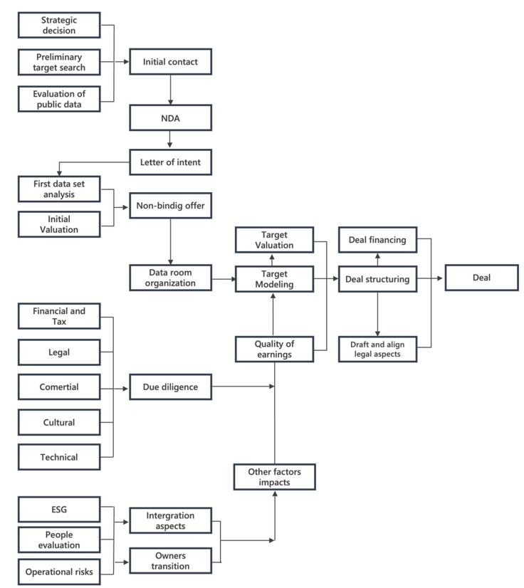

Summarised process- investors perspective
- Receipt and review of the teaser
- Execution of the NDA
- Issuance of an Expression of interest or letter of intent or email confirming interest in the deal and requesting additional information.
- Data room access
- Conduct preliminary due diligence
- Preparation of internal IC paper
- First IC approval
- Issuance of non-binding term sheet.
- Execution of the term sheet.
- Onsite detailed due diligence – this may be undertaken internally, or they may hire external consultants such as big 4 audit firms to undertake financial, tax, commercial, ESG, Legal DD etc
- Second IC Approval
- Issuance of a binding offer.
- Issuance of loan agreement of Share purchase agreement.
- Seeking approval from competition authority – i.e notifying CAK or COMESA

